The functional structure diagram is used to illustrate the main functions of the Hotel Reservation Management System and how they are organized into different modules. It provides a clear overview of the system's functional scope before detailed development begins.
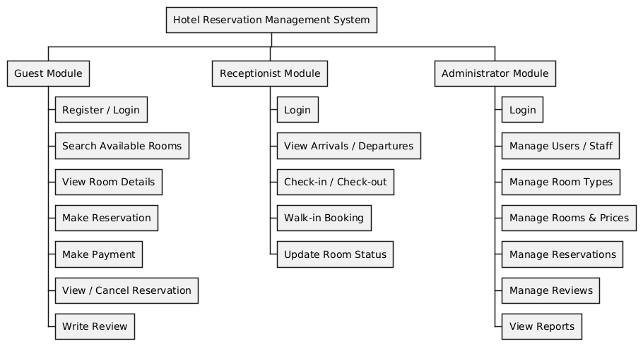
Figure 2 Functional Structure Diagram of the Hotel Reservation Management System
As shown in Figure 2, the system is divided into three main modules: Guest, Receptionist, and Administrator. The Guest module handles user registration, login, room searching, reservation, payment simulation, and review submission. The Receptionist module manages daily hotel operations, including viewing arrivals and departures, check-in, check-out, walk-in booking, and room status updates. The Administrator module provides management functions such as managing users, staff, room types, rooms, prices, reservations, reviews, and viewing operational reports.

The system architecture diagram is used to show the overall structure of the system, including the client layer, application layer, and data layer. It explains how users interact with the system and how data flows between different components.
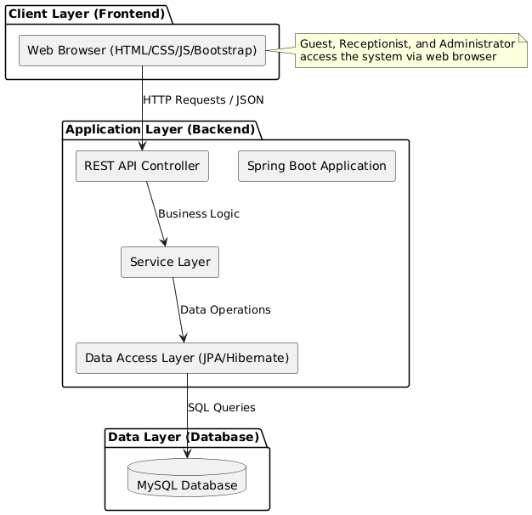
Figure 3 System Architecture Diagram of the Hotel Reservation Management System
As shown in Figure 3, the system follows a three-tier architecture. The Client Layer (Frontend) is developed using HTML, CSS, JavaScript, and Bootstrap, allowing Guests, Receptionists, and Administrators to access the system through a web browser. The Application Layer (Backend) is built with Spring Boot, which includes the REST API Controller, Service Layer, and Data Access Layer. The backend receives HTTP requests from the frontend, processes business logic, and interacts with the database. The Data Layer uses MySQL to store and manage all system data, including users, rooms, reservations, payments, and reviews. The frontend and backend communicate through REST APIs using JSON format.

